Your unit at Opus Broadbeach will come fully equipped and ready to be connected to the National Broadband Network or NBN through a Retail Service Provider.
It is important to understand the difference between the NBN and a Retail Service Provider. The NBN is an infrastructure network where a Retail Service Provider, or RSP, is a company that you may choose to provide you with internet, phone or a combination of the two.
The NBN Corporation’s website is a helpful place to start in looking for an RSP. The following is an address that takes you straight to their listed RSPs:
https://www.nbnco.com.au/connect-home/service-providers.html
Morris Property Group understands that connecting to the NBN can be a complicated process and has therefore provided to the Building Manager and to each Unit owner their unique LOC Identification numbers. This expedites the process of the RSP finding your address in the NBN database.
When talking to your prospective RSP, let them know straight away that you already have the LOC ID number. They may still wish to verify the physical address. This address for the whole building is known as: 18 Chelsea Avenue, Broadbeach QLD 4218. As Opus Broadbeach is a brand new development, some data-bases may have not been updated to show what NBN’s map displays:
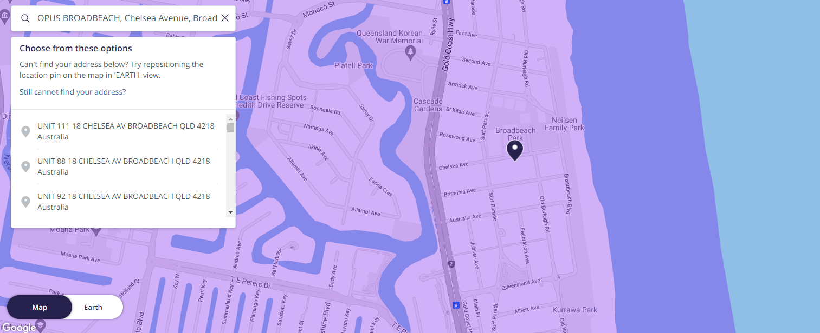

Should you require more information on your NBN connection, there are many places you can go. A copy of the following documents developed by NBN Corporation has been provided for your information:
- NBN Connect Kit for MDU Homes.pdf and
- NBN Fibre User Guide.pdf

